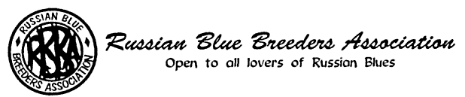
NOMINATION FORM

NAME OF NOMINEE: ……… ...........................................................................................................

POSITION FOR WHICH NOMINATED:.…….....................................................................................

NOMINATED BY:

1. NAME ……………………….................. SIGNATURE ………………………..................

2. NAME ……………………….................. SIGNATURE ………………………..................

PERSONAL DETAILS OF NOMINEE

a) Date joined the RBBA (if known) ……………........………………………………………

b) Office, Committee membership or other Association posts now or in the past and period held

…………………………………………………………………………………………

- Offices, or Committee memberships presently held in other cat clubs: .........................

………………………………………………………………………………………....

d) Other relevant qualifying factors, e.g. Russian Blue Judge, past Secretaryships in other organisations, experience in Show Management etc:

I confirm that the above details are correct, that I am not on the Committee of more than two other cat clubs and I accept nomination for the position above.

SIGNATURE OF NOMINEE ................................................................. DATE ...........................

Please return the completed form to the Hon. Secretary:
Miss Angela Cooper
Email: angie.cooper@blueyonder.co.uk

No later than Saturday 9th April 2022

